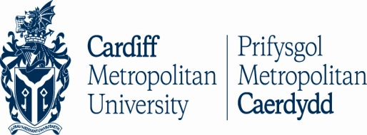
International Student Week
13th – 17th April 2015

UNIVERSITY NAME:
NAME:
GENDER: MALE / FEMALE
DATE OF BIRTH:
EMAIL ADDRESS:
MOBILE PHONE NUMBER:

Please tick which package you would like to book. Package 1 or Package 2
Package 1. £ 220 including 5 nights (Sunday to Friday) accommodation and breakfast. Please identify below if you wish to book additional days as the price will change.

Additional information (e.g room booking for Friday night)
________________________________________________________________________________________________________________________________________________________________________________________________________
Package 2. £ 105 excluding accommodation and breakfast

PAYMENT INFORMATION
Payment will need to be made via bank transfer no later than 2 weeks after your application has been accepted. You will receive Cardiff Met payment details with your acceptance letter.
Accommodation will be booked once payment is received. If you wish to cancel your booking please note that you will only receive a partial refund.

